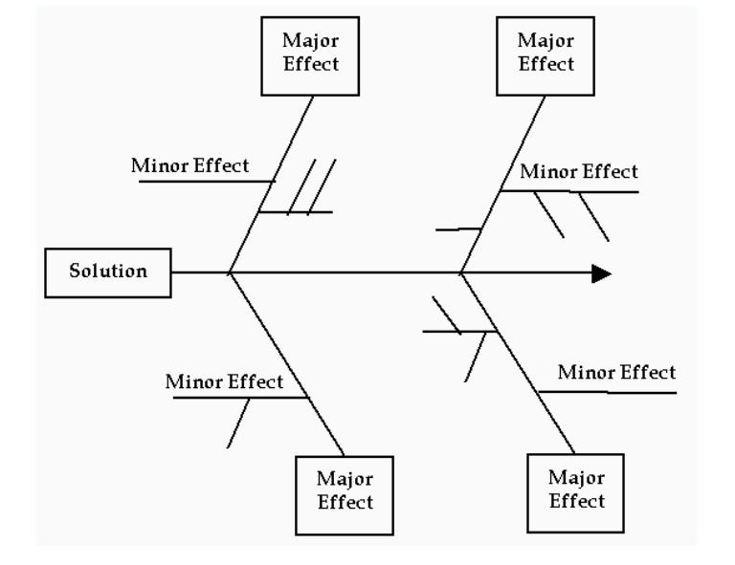
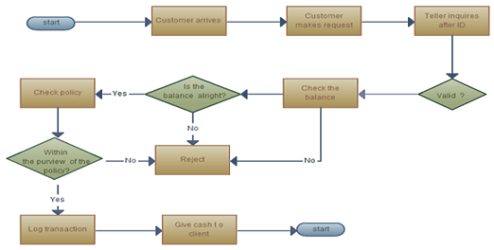

Introduction to Quality Tools

Student Supplement

Topics in Tactical Management


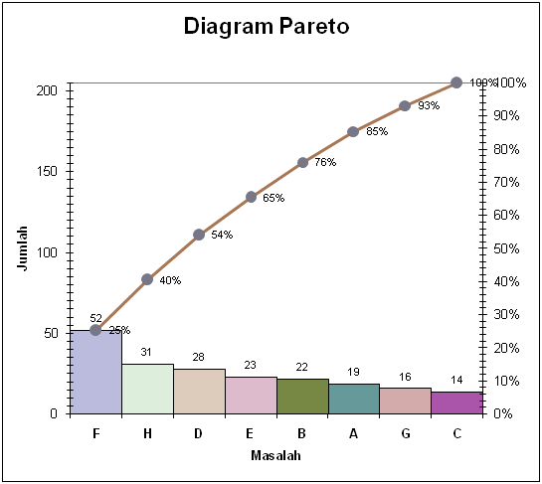
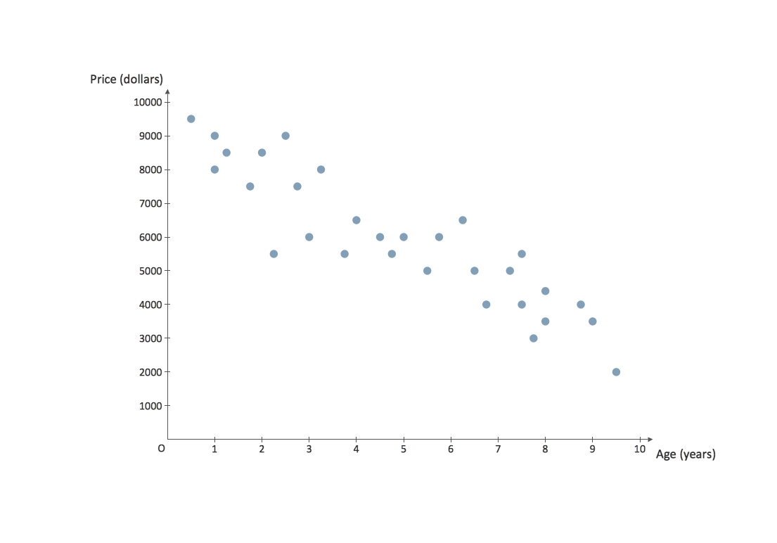
1. Plan Do Study Act Cycle

**CHECK that you have and answered every question for each question.**

Plan is the first step, which the problem is defined, data is gathered, causes are identified, and potential solutions are generated.

Consider the problem of employees arriving late to work (you will use this example throughout this supplement).

How might you describe this problem (i.e., what have you seen at work, or use creative license)?
Add answers in a different color font.

Problem definition:

- What: Employees late for scheduled shifts

- Who: Evening employee’s

- When: Evening Shift (4pm or late)

- Where: Restaurant

- Why is it a problem: Customer orders are slower than are goal. Morale of employee is hurt because some must stay longer until the others have arrived and ready to work.

- Problem Statement: Evening shift employees at the restaurant are not ready to work at their scheduled times.

- Goal Statement (do not include solutions): All employee’s must be present and ready to work by their scheduled shift time.

Check that your goal is SMARTER: Specific, Measurable, Agreed upon/ Acceptable/Aligned with corporate strategies and customer specifications, Realistic, Time-bound, Ethical, and Recorded
- Revised Goal Statement (do not include solutions): Effective March 1, 2020 all employee’s must arrive and be ready to work at there deployed position by their schedule time.

- Operational Definition (do not include solutions): On time is for all team members to be in uniform before they clock in. Once they have clocked in, they need to be in their deployed position and setup.
Verify that your Operational definition is SMARTER. Your Operational Definition should be clear, concise and drive employee behavior.
2. Flowchart
https://creately.com/diagram-examples
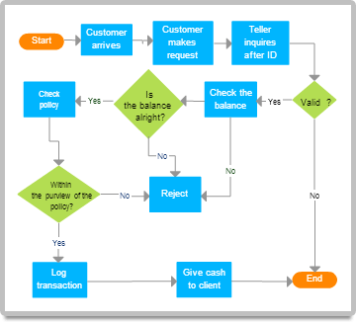
Draft a flowchart for an individual arriving to work.
Requirements and Tips:
- You are only flowcharting the basic process of getting to work, not the causes of being late.
- You may start the process as early as the night before if you believe activities from the night before are relevant to the problem of arriving late to work.
- Your flowchart should end with arriving at work.
- Your chart must have 5 tasks and at least one decision.
- There should only be one finish oval.
- Arrange your tasks so if they only occur once there is only one rectangle.
- Remember a decision diamond must have only one yes/go and one no/no go out arrow.
- All connected symbols must end with a finish oval.

Example: this could be the start of a flowchart, don’t re-use this example. This is only a partial flowchart; you need more than this.

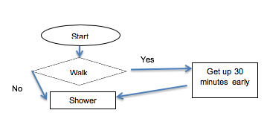
Decision
Task/Activity
Start/finish

Start

Did the Alarm go off?
Sleep

NO

YES
Call work to let them know your running late

Get ready for work

Get ready for work

Leave for Bus stop

Eat

Leave for Bus stop

Arrive to work

3. Affinity Diagram
https://wiki.fluidproject.org/display/fluid/Affinity+Diagrams
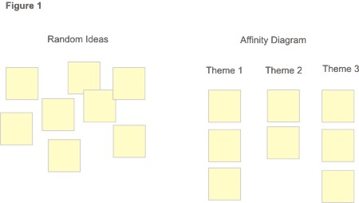
- Identify as many ideas as you can as to why individuals might arrive late to work:
Traffic slow due to snow
Find a sitter no school due to weather

Took too long to get ready
Missed the bus
Snoozed Alarm

Took too long to eat
Bus running late
Alarm not set

Bus slowed down by weather or accident
Slept through alarm
Roommate using the bathroom

- How would you label each major grouping?

Theme 1 Alarm/ sleeping issues
Theme 2 Bus issues
Theme 3 Routine issues

4. Cause and Effect: Fishbone
https://business.tutsplus.com/articles/get-started-with-cause-and-effect-analysis-using-a-fishbone-chart--cms-21178

- Complete a Cause and Effect exercise. The cause and effect or fishbone is shown. For ease of completing exercise, use the rows and column table below that has already been started for you.

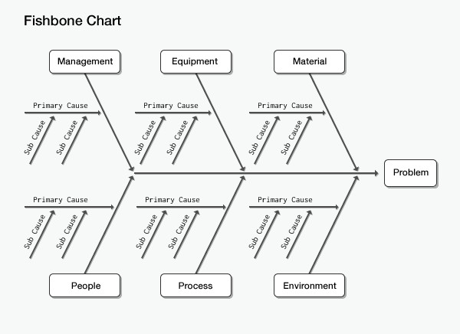
Requirements and Tips:
- In completing a cause and effect diagram, the question WHY is typically asked 5 times. (NOTE: Asking why 5 times is a guide. If you believe you’ve determined the root cause after asking why only once or twice, that is fine.)
- In manufacturing, the main headers could be: machine, methods, materials, and people, or measurement. In an office setting, headers could be: policies, procedures, systems, process, supplies, or skills. You can use the standard headers to assist you in brainstorming the root causes or use headers from previous brainstorming (e.g. your affinity diagram).

DO not complete this chart. Complete the table below.

Employees arrive late at work
Effect

The purpose of a fishbone to is to force questions to assist in finding a root cause vs. assuming the initial cause that may seem obvious is the root cause. Asking why 5 times is meant to be a process that by the time you have asked why at least five times, you should have dove deep enough to find the true root causes. You may not need to ask why 5 times for each minor bone*, especially when the same root cause continues to appear for each major bone##. When completing a fishbone with more people, you would have potentially more answers to the whys; therefore, asking why five times might be appropriate.

The purpose of completing the fishbone for this assignment is not to frustrate anyone by trying to figure out how to complete the bones using a software package. The purpose is to take each primary cause and ask why to find root causes.

For each bone, you ask why until you believe you have identified the root cause. Use the table below vs struggling to complete the fishbone diagram. Clearly identify your root cause(s) as I have.

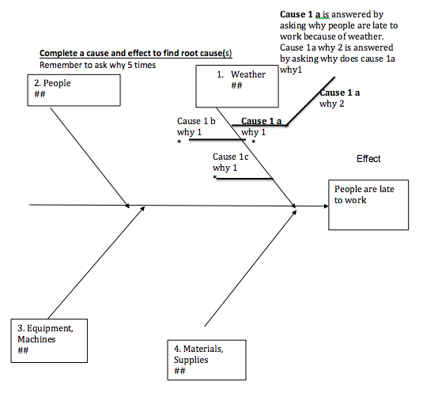
Effect- People are late to work

I have completed a few, please leave those at part of your submission. Add your own causes using the methodology I used in Cause 1 a.
 | Why 1 | Why 2 | Why 3 | Why 4 | Why 5
Cause 1 a  Environment/  Weather | Why did weather cause you to be late?  Didn’t know forecast | Why didn’t you know the forecast?  Didn’t watch weather | Why didn’t you watch the weather?  Didn’t care | Why don’t you care?  No consequences for being late- potential root cause
Cause 1 b  Environment/  Weather | Why did the weather cause you to be late? Bus was late due to weather | Why didn’t you know the bus was late?  Didn’t expect weather to delay transportation | I was with my friends and didn’t check | Why don’t you care? Thought everyone would be late due to the weather. | No consequences
Cause 1 c  Environment/  Weather | Why did the weather cause you to be late? Accident on the way to work | Didn’t expect an accident due to weather to slow us down | Why didn’t you let us know you would be late | No consequence for be late.
Cause 2a  People | Why are you late?  Stayed out to late | Why did staying out late cause you to be late to work?  Couldn’t get up on time. | Why don’t you care about getting up on time?  No consequences for being late- potential root cause
Cause 2b  People | Why are you late?  Took to long to get ready | Why did it take so long to get ready?  Roommate was using the bathroom. | Why didn’t you inform your roommate you needed the bathroom | Why don’t you care about not be present on time? No consequences
Cause 2c  People | Why are you late?  Forgot to set the alarm. | Why did you forget to set alarm?  Stay up to late and fell asleep on my couch | Why didn’t you set the alarm earlier?  Thought I would wake up at some point | No consequence
Cause 3a  Equipment and machines | Alarm didn’t go off | Building lost power due to weather

- What are the potential root causes based on the completed cause and effect diagram/table?

Everything for the most part leads to the root cause being no consequences. With that be said I think this points to having to put together an action plan to get this changed and everyone on the same page. Another root cause could be weather if that is an issue at the time.

5. Interrelationship Digraph
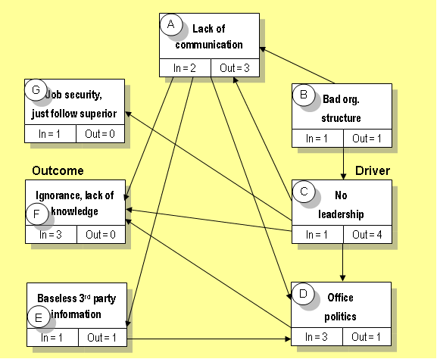
Complete an interrelationship –
diagraph on arriving late to work:
ANSWER all three questions.
- Write in your primary causes from affinity exercise and cause and effect; draw your arrows; complete # arrows in/out.

- Which cause(s) has the most out arrows or is your driving cause?
Lack of company polices to hold everyone accountable

- Which causes have more in arrows, meaning an outcome or effect?

Low payment and weather

Requirements and Tips:
- An arrow can only go one way between two header boxes.
- Drivers have arrows going out and effects have arrows going in.
- Remember to ask the relationship between each set of boxes.

Let’s get started. When we look at the cause and effect, you can see that weather was the original cause listed on the left column of the table. After asking why, the root cause was determined that no consequences cause us not to care about being late and not taking the time to look at the forecast. The relationship between weather and no consequences is that weather is the outcome or what appears to be making us late but in reality have no consequences is the actual driver; therefore the arrow would go from No consequences to weather.

Let’s look at another. From the affinity exercise, I gave you the major header attitude toward job. Again we want to look at relationship between the major causes selected of weather and attitude toward job. Does weather cause us to be late and the outcome is an attitude toward work or is the attitude toward work the driver and weather is the outcomes or what appears to be making us late? I would say attitude toward work makes us not care and weather is the outcome or what appears to be making you late. The arrow should be drawn from attitude toward work to weather.

Thinking through this, if the consequences were significant enough, employees would watch the weather, and the weather cause would be an outcome of no consequences. No consequences would be the driver; therefore, the arrow goes from no consequences to weather. You do not need to explain each arrow as I. I only did that to assist you with understanding how the model works. DO NOT remove Weather and No consequences from the diagram. Add your additional causes and include weather and no consequences in your analysis.

Now the tricky part comes, what is the relationship if any between no consequences and attitude toward work. Does no consequence cause us to be late with the outcome of an attitude toward work or does attitude toward work have an outcome of no consequences. If the brainstorming group states that I hate my job because there are no policies and procedures, then the arrow would be drawn from no consequences to attitude toward work, again no consequences being the driver. If the group states having no consequences has no impact why I hate my job or people I work with, then no line is drawn between the two causes.

Now that I have given you a start with a few causes, directions of the arrows and relationships, finish the diagram with at least three more causes. Remember to complete 5.1, 5.2, and 5.3.

Leave no consequences as a cause. 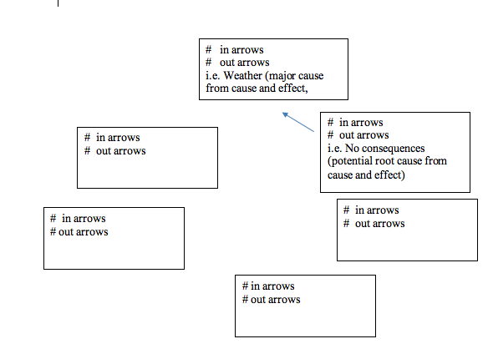 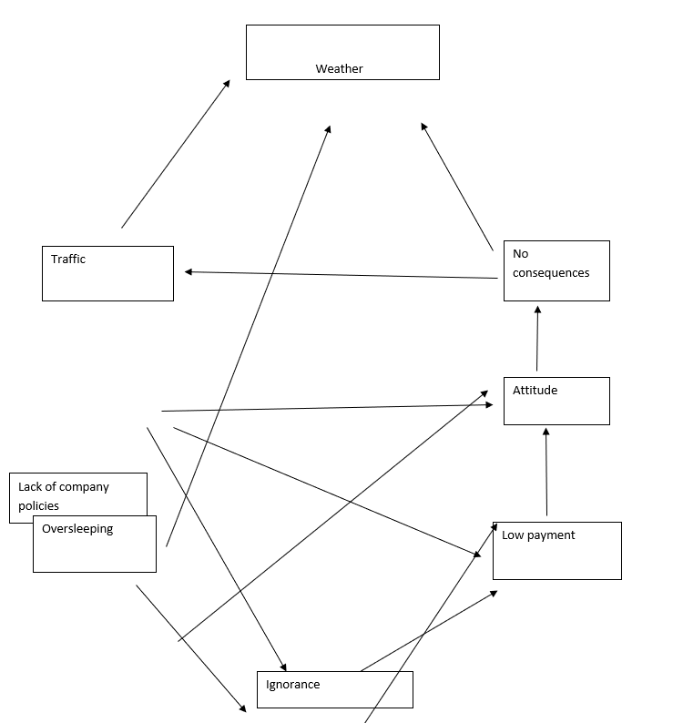
6. Check Sheet
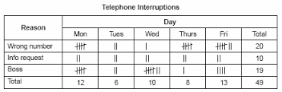
http://asq.org/learn-about-quality/data-collection-analysis-tools/overview/check-sheet.html

Create a check sheet using the data below.

Requirements and Tips
- The individual using the check sheet tool needs to know when to put a tally mark, this is where operational definition is helpful (question 1.9).
- Focus on tallying the causes as if you were an employee completing the checksheet daily.
- Use the data below to complete the checksheet. Use tally marks in the checksheet. Reference picture above.
- Do not change the data.
- Enter the root and driving causes (from, fishbone, interrelationship) on the top row.

No consequences | Cause 2:  Weather | Cause 3:  Attitude | Cause 4:  Oversleeping | Cause 5:  Traffic
3 | 2 | 0 | 0 | 0
7 | 2 | 1 | 1 | 1
7 | 3 | 2 | 1 | 1
0 | 0 | 0 | 0 | 0
12 | 8 | 3 | 1 | 1
3 | 3 | 4 | 0 | 0
For this checksheet, you are concerned about cause total not the who.
Cause | Tally | Total
No Consequences | //////////////////////////////// | 32
Weather | ////////////////// | 18
Attitude | ////////// | 10
Oversleeping | /// | 3
Traffic | /// | 3
7. Pareto Chart #1

The following is an example of a completed chart.

Cause | No. of Absences | Cumulative | Percentage | Cumulative
Weather | 15 | 15 | 31% | 31%
Illness | 12 | 27 | 24% | 55%
Family Issues | 11 | 38 | 22% | 77%
Day Care | 7 | 45 | 14% | 91%
Bereavement | 4 | 49 | 8% | 99%
Total | 49 |  | 99%

Note: The total does not equal 100% due to rounding error.

Diagram #1

Cumulative %
 | 20 |  |  |  |  |  |  |  |  |  |  |  |  |  | 99 | 99 | 100
Y - Frequency of Occurrence | 19 |  |  |  |  |  |  |  |  |  |  |  |  |  |  |  | 95
Y - Frequency of Occurrence | 18 |  |  |  |  |  |  |  |  |  |  | 91 |  |  |  |  | 90
Y - Frequency of Occurrence | 17 |  |  |  |  |  |  |  |  |  |  |  |  |  |  |  | 85
Y - Frequency of Occurrence | 16 |  |  |  |  |  |  |  |  |  |  |  |  |  |  |  | 80
Y - Frequency of Occurrence | 15 |  |  |  |  |  |  |  | 77 |  |  |  |  |  |  |  | 75
Y - Frequency of Occurrence | 14 |  |  |  |  |  |  |  |  |  |  |  |  |  |  |  | 70
Y - Frequency of Occurrence | 13 |  |  |  |  |  |  |  |  |  |  |  |  |  |  |  | 65
Y - Frequency of Occurrence | 12 |  |  |  |  |  |  |  |  |  |  |  |  |  |  |  | 60
Y - Frequency of Occurrence | 11 |  |  |  |  | 55 |  |  |  |  |  |  |  |  |  |  | 55
Y - Frequency of Occurrence | 10 |  |  |  |  |  |  |  |  |  |  |  |  |  |  |  | 50
Y - Frequency of Occurrence | 9 |  |  |  |  |  |  |  |  |  |  |  |  |  |  |  | 45
Y - Frequency of Occurrence | 8 |  |  |  |  |  |  |  |  |  |  |  |  |  |  |  | 40
Y - Frequency of Occurrence | 7 |  |  |  |  |  |  |  |  |  |  |  |  |  |  |  | 35
Y - Frequency of Occurrence | 6 |  | 31 |  |  |  |  |  |  |  |  |  |  |  |  |  | 30
Y - Frequency of Occurrence | 5 |  |  |  |  |  |  |  |  |  |  |  |  |  |  |  | 25
Y - Frequency of Occurrence | 4 |  |  |  |  |  |  |  |  |  |  |  |  |  |  |  | 20
Y - Frequency of Occurrence | 3 |  |  |  |  |  |  |  |  |  |  |  |  |  |  |  | 15
Y - Frequency of Occurrence | 2 |  |  |  |  |  |  |  |  |  |  |  |  |  |  |  | 10
Y - Frequency of Occurrence | 1 |  |  |  |  |  |  |  |  |  |  |  |  |  |  |  | 5
Y - Frequency of Occurrence |  | Weather |  |  | Illness |  |  | Family Issues |  |  | Day  Care |  |  | Bereavement
 |  | X-Causes

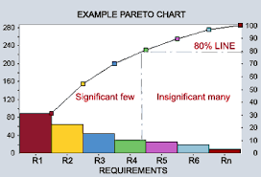
Diagram #2

Create a pareto for individuals arriving late for work.

 | # of occurrences | Total
No consequences | xxxxxxxxxxxxxxxxxxxxxxxxxxxxxxxx | 32
Cause 2 | xxxxxxxxxxxxxxxxxx | 18
Cause 3 | xxxxxxxxxx | 10
Cause 4 | xxx | 3
Cause 5 | xxx | 3

- Using data from the checksheet above, complete the information below. Causes are from your checksheet #6 exercise which should be your root causes and drivers from the cause and effect and interrelationship diagram. Leave no consequences as a root cause.

Cause | Number of  Occurrences | Cumulative  Occurrences | Individual % | Cumulative %
No Consequences | 32 | 32

- Record your data in the Pareto Chart. (Note: You can highlight cells and change the colors or you can use Excel and insert a Pareto using this data.)

- Interpret the chart: What does the chart tell you about the primary cause of individuals arriving late to work?

Requirements and Tips:
- Sort your data from highest to lowest.
- Include a line and include the % on the chart for each data point.

Cumulative %
 |  |  |  |  |  |  |  |  |  |  |  |  |  |  | 99 |  | 100
Y - Frequency of Occurrence |  |  |  |  |  |  |  |  |  |  |  |  |  |  |  |  | 95
Y - Frequency of Occurrence |  |  |  |  |  |  |  |  |  |  |  |  |  |  |  |  | 90
Y - Frequency of Occurrence |  |  |  |  |  |  |  |  |  |  |  |  |  |  |  |  | 85
Y - Frequency of Occurrence | 32 |  |  |  |  |  |  |  |  |  |  |  |  |  |  |  | 80
Y - Frequency of Occurrence | 30 |  |  |  |  |  |  |  |  |  |  |  |  |  |  |  | 75
Y - Frequency of Occurrence | 28 |  |  |  |  |  |  |  |  |  |  |  |  |  |  |  | 70
Y - Frequency of Occurrence | 26 |  |  |  |  |  |  |  |  |  |  |  |  |  |  |  | 65
Y - Frequency of Occurrence | 24 |  |  |  |  |  |  |  |  |  |  |  |  |  |  |  | 60
Y - Frequency of Occurrence | 22 |  |  |  |  |  |  |  |  |  |  |  |  |  |  |  | 55
Y - Frequency of Occurrence | 20 |  |  |  |  |  |  |  |  |  |  |  |  |  |  |  | 50
Y - Frequency of Occurrence | 18 |  |  |  |  |  |  |  |  |  |  |  |  |  |  |  | 45
Y - Frequency of Occurrence | 16 |  |  |  |  |  |  |  |  |  |  |  |  |  |  |  | 40
Y - Frequency of Occurrence | 14 |  |  |  |  |  |  |  |  |  |  |  |  |  |  |  | 35
Y - Frequency of Occurrence | 12 |  |  |  |  |  |  |  |  |  |  |  |  |  |  |  | 30
Y - Frequency of Occurrence | 10 |  |  |  |  |  |  |  |  |  |  |  |  |  |  |  | 25
Y - Frequency of Occurrence | 8 |  |  |  |  |  |  |  |  |  |  |  |  |  |  |  | 20
Y - Frequency of Occurrence | 6 |  |  |  |  |  |  |  |  |  |  |  |  |  |  |  | 15
Y - Frequency of Occurrence | 4 |  |  |  |  |  |  |  |  |  |  |  |  |  |  |  | 10
Y - Frequency of Occurrence | 2 |  |  |  |  |  |  |  |  |  |  |  |  |  |  |  | 5
 |  | X-Causes

8. Pareto Chart #2
Practice making a Pareto. The data in this Pareto is not part of the arriving late to work case. You are just practicing completing a Pareto again.
- Complete the analysis below:

Cause | Number of  Accidents | Cumulative  Occurrences | Individual % | Cumulative %
Student Driver | 42
Drunk Driver | 31
Weather | 21
Twilight | 18
Speeding | 14
Tailgating | 9
Mechanical | 7

- Complete the chart below.

- Interpret the chart. What does this Pareto Analysis tell you about the problem of accidents?

Cumulative %
Y - Frequency | 50 |  |  |  |  |  |  |  |  |  |  |  |  |  |  |  |  |  |  |  |  |  | 100
Y - Frequency | 48 |  |  |  |  |  |  |  |  |  |  |  |  |  |  |  |  |  |  |  |  |  | 96
Y - Frequency | 46 |  |  |  |  |  |  |  |  |  |  |  |  |  |  |  |  |  |  |  |  |  | 92
Y - Frequency | 44 |  |  |  |  |  |  |  |  |  |  |  |  |  |  |  |  |  |  |  |  |  | 88
Y - Frequency | 42 |  |  |  |  |  |  |  |  |  |  |  |  |  |  |  |  |  |  |  |  |  | 84
Y - Frequency | 40 |  |  |  |  |  |  |  |  |  |  |  |  |  |  |  |  |  |  |  |  |  | 80
Y - Frequency | 38 |  |  |  |  |  |  |  |  |  |  |  |  |  |  |  |  |  |  |  |  |  | 76
Y - Frequency | 36 |  |  |  |  |  |  |  |  |  |  |  |  |  |  |  |  |  |  |  |  |  | 72
Y - Frequency | 34 |  |  |  |  |  |  |  |  |  |  |  |  |  |  |  |  |  |  |  |  |  | 68
Y - Frequency | 32 |  |  |  |  |  |  |  |  |  |  |  |  |  |  |  |  |  |  |  |  |  | 64
Y - Frequency | 30 |  |  |  |  |  |  |  |  |  |  |  |  |  |  |  |  |  |  |  |  |  | 60
Y - Frequency | 28 |  |  |  |  |  |  |  |  |  |  |  |  |  |  |  |  |  |  |  |  |  | 56
Y - Frequency | 26 |  |  |  |  |  |  |  |  |  |  |  |  |  |  |  |  |  |  |  |  |  | 52
Y - Frequency | 24 |  |  |  |  |  |  |  |  |  |  |  |  |  |  |  |  |  |  |  |  |  | 48
Y - Frequency | 22 |  |  |  |  |  |  |  |  |  |  |  |  |  |  |  |  |  |  |  |  |  | 44
Y - Frequency | 20 |  |  |  |  |  |  |  |  |  |  |  |  |  |  |  |  |  |  |  |  |  | 40
Y - Frequency | 18 |  |  |  |  |  |  |  |  |  |  |  |  |  |  |  |  |  |  |  |  |  | 36
Y - Frequency | 16 |  |  |  |  |  |  |  |  |  |  |  |  |  |  |  |  |  |  |  |  |  | 32
Y - Frequency | 14 |  |  |  |  |  |  |  |  |  |  |  |  |  |  |  |  |  |  |  |  |  | 28
Y - Frequency | 12 |  |  |  |  |  |  |  |  |  |  |  |  |  |  |  |  |  |  |  |  |  | 24
Y - Frequency | 10 |  |  |  |  |  |  |  |  |  |  |  |  |  |  |  |  |  |  |  |  |  | 20
Y - Frequency | 8 |  |  |  |  |  |  |  |  |  |  |  |  |  |  |  |  |  |  |  |  |  | 16
Y - Frequency | 6 |  |  |  |  |  |  |  |  |  |  |  |  |  |  |  |  |  |  |  |  |  | 12
Y - Frequency | 4 |  |  |  |  |  |  |  |  |  |  |  |  |  |  |  |  |  |  |  |  |  | 8
Y - Frequency | 2 |  |  |  |  |  |  |  |  |  |  |  |  |  |  |  |  |  |  |  |  |  | 4
 | X - Causes

9. Scatter Diagram #1

Times late | Age of children
3 | 15
2 | 17
16 | 2
17 | 2
15 | 1
13 | 5
12 | 6
11 | 7
10 | 8
9 | 9
9 | 10
9 | 11
9 | 12
7 | 12
5 | 13
5 | 14
3 | 15
4 | 16
1 | 16
15 | 4
1 | 18
- Complete the scatter diagram.
- Scale and label the X axis with the cause variable = age of children. Start with 0 to the oldest age listed.
- Scale and Label Y axis with the effect variable = times late. Start with 0 to highest number of occurrences.

- Interpret the chart. What does the data tell you?

99
Y - Frequency of Occurrence effects
X-Causes

10. Scatter Diagram #2

An employer wishes to determine whether there is any relationship between the age of an employee and the number of days of work the employee misses during the year. He collected the following data from the absence reports.

- Draw a Scatter Diagram using the data provided below.

- Interpret the diagram. What is the correlation between the ages of the employees and the absences?

Independent Variable X | Age of Employee | 22 | 30 | 25 | 35 | 65 | 50 | 27 | 53 | 42
Dependent Variable Y | Days Missed | 0 | 4 | 1 | 2 | 14 | 7 | 3 | 8 | 6

Scatter Diagram

 | 20
Y Variable (Absences) | 19
Y Variable (Absences) | 18
Y Variable (Absences) | 17
Y Variable (Absences) | 16
Y Variable (Absences) | 15
Y Variable (Absences) | 14
Y Variable (Absences) | 13
Y Variable (Absences) | 12
Y Variable (Absences) | 11
Y Variable (Absences) | 10
Y Variable (Absences) | 9
Y Variable (Absences) | 8
Y Variable (Absences) | 7
Y Variable (Absences) | 6
Y Variable (Absences) | 5
Y Variable (Absences) | 4
Y Variable (Absences) | 3
Y Variable (Absences) | 2
Y Variable (Absences) | 1
Y Variable (Absences) |  | 5 | 10 | 15 | 20 | 25 | 30 | 35 | 40 | 45 | 50 | 55 | 60 | 65 | 70 | 75 | 80 | 85 | 90 | 95 | 100
 |  | X Variable (Ages)

Source: Passiac County Community College, Passiac, New Jersey

# of
People
late
M | 6
T | 1
W | 2
R | 2
F | 1
M | 7
T | 2
W | 3
R | 1
F | 2
M | 10
T | 1
W | 3
R | 2
F | 3
M | 7
T | 2
W | 3
R | 4
F | 2
11. Run Chart
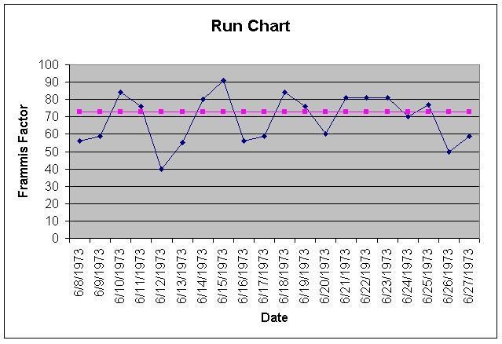

- Complete a run chart by documenting the number of people late over the past three weeks. (NOTE: The chart has been started for you.)

- Calculate the average number of people who are late each day by totaling the number of absences and dividing by the number of occurrences.

- Draw the average line on the chart.

- Interpret the chart:

2
1
0 | M | T

12. Pareto

Create a Pareto diagram using the number of people late by day (the diagram has been started for you). You will need to adjust your Y scale to increments of 2.

Requirements and Tips:
- Remember the power of a Pareto is having the data sorted highest to lowest.
- Make sure to include the accumulation line and interpret the chart.

Cause | Number of  Occurrences | Cumulative  Occurrences | Individual  % | Cumulative  %
- Complete the table below
- Create a Pareto diagram
- Interpret the chart. What does the data tell you?

# of
People
late
M | 6
T | 1
W | 2
R | 2
F | 1
M | 7
T | 2
W | 3
R | 1
F | 2
M | 10
T | 1
W | 3
R | 2
F | 3
M | 7
T | 2
W | 3
R | 4
F | 2
Remember to sort data highest to lowest

99
4
2
Days of the week

13. Histogram and Central Tendency
Times late
3
2
16
17
15
13
12
11
10
9
9
9
9
7
5
5
3
4
1
15
1

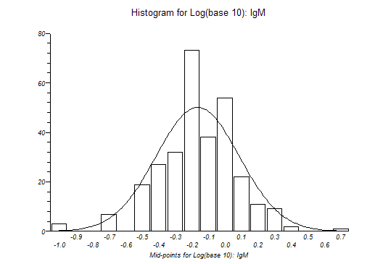
Complete the following:

- Total value of all data points
- Average = Total value of data points/ number of data points
- Mode = The mode is the number that occurs most frequently in the data set
- Range = The range is calculated by identifying the highest number and subtracting the lowest number
- Median = The middle data point | Sort data from lowest to highest and record below

Find the Median by completing this row (the 1’s have been recorded for you):
1 | 1

- Record the data on the chart. The data points have a range from 1 to 17. (You will start by numbering the bottom scale of the chart. Then record the data points on the chart. The 1’s have been recorded for you).

- Interpret the chart. What does the data tell you?

X
X
1 | 2 | 3 | 4

14. Implementation Plan

Create an implementation plan (items 1-13) for Arriving late at work:

- To keep a focus on the original goal, rewrite your revised goal here. Make sure to look at gradebook and revise your goal based on my feedback (page 1):

- Based on data analysis throughout this supplement, what are the root causes of arriving late? (Remember to look the interrelationship diagram which took the root causes from the cause and effect to find the true drivers/root causes and look at gradebook for my feedback.)

,

- What are the decision criteria you will use to help select between potential solutions?
When considering decision criteria:
- Remember decision criteria are not solutions. Think about the car case example where decision criteria were $25,000 or below, 35 mpg, and holds 5 people etc.
- Typically, criteria relate to budget, customer satisfaction, employee morale, time bound, or other KPIs and the criteria are SMART.

Employee Morale: no one losses their job
Budget:
Customer Satisfaction:
Timebound (by when):
Quality:

- What are possible solutions to reach your goal and address the root causes?

- Draft a decision matrix comparing decision criteria to alternatives/ solutions. (Your student supplement explains decision matrices and you completed an assignment on this.) Add columns and rows as needed. If you use a rating scale, add a legend.

 | No one losses their job | Add Your Criteria 2: | Add Your Criteria 3: | Add Your Criteria 4. | Total
New Polices and procedures (addresses #1 root cause of no consequences) | x
Add Your Solution 2:
Add Your Solution 3:

- Pick your best solution(s) based on your decision matrix.

- What are the trolls, fears, and/or cons that may make the implementation challenging or not successful?

- What are your plans to minimize the impact of the trolls, fears, or cons?

- Draft an implementation plan with tasks and due dates (add rows as needed): Remember new policies and procedures need to go through HR. Use the table.

Tasks (What) | Responsibilities (Who) | Due Dates (When)

- Implementation is the Do step of the PDSA cycle. NOTE: you do not need to take action on this step of the cycle.

- Check, follow-up on progress or Study is the next step of the PDSA cycle. How will you follow-up to ensure your implementation is successful? What data will you collect to compare to your baseline (hint consider your main KPI)?

- Act is the last step of the PDSA cycle. Changes are standardized through written procedures, SOP’s or the implementation of additional changes needed to meet or exceed the goal. What policies or procedures do you need or how will you standardize your change?

- After the implementation of your solution, what is the next improvement you might consider (basically starting the PDSA cycle again)? This ensures you are keeping a continuous improvement mindset.

